HANDS Workshop

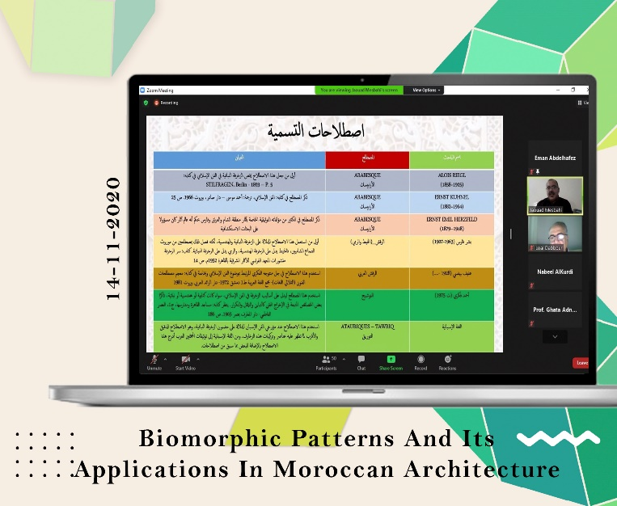
Workshop / Biomorphic Patterns and its Applications in Moroccan Architecture

WP 6: DEVELOPMENT
Date: Saturday, 14/11/2020
Organizer: Al-Zaytoonah University of Jordan
Location: Online via Zoom
As part of HANDS activities, an online lecture entitled "Biomorphic Patterns and its Applications in Moroccan Architecture" was presented by Mr. Jawad Mesbahi, a master craftsman from Morocco, on 14th November 2020. This lecture was attended by fifty-five participants (students and faculty members) from Jordanian and Syrian universities.

